**WORK FLOW**



**WORK FLOW**

**1.    COST ESTIMATIONS**

**2.    QUOTATION TO CUSTOMER**

**3.    SALES ORDER**

**A.    SUPPLY OUTWARD**

**4.    PURCHASE /WORK ORDER**

**A.    PURCHASE ORDER (JOB WORK PRINTING)**

**B.    PURCHASE /WORK ORDER (IN HOUSE/FG)**

**5.    MATERIAL IN**

**A.    JOB WORK (PRINTED SHEETS)**

**B.    SUPPLY IN (FINISHED GOODS)**

**6.    MATERIAL OUT**

**A.    SUPPLY OUT**

**7.    SALES**

**A.    SUPPLY OUTWARD**

**->>CLICK ON EASYPUBLISH.EXE OR SOFTWARE SHORTCUT**

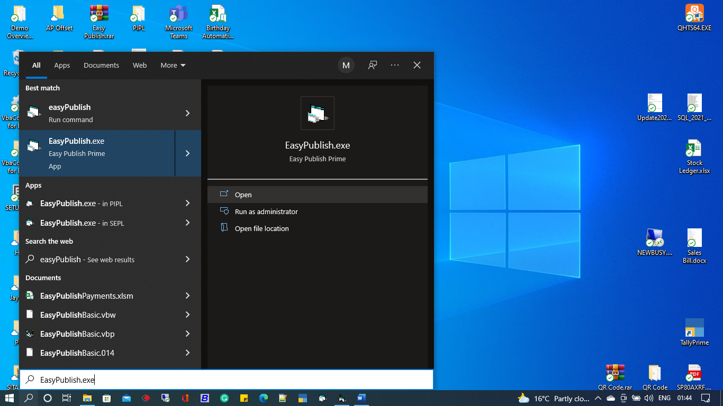

**->>CLICK ON OPEN**

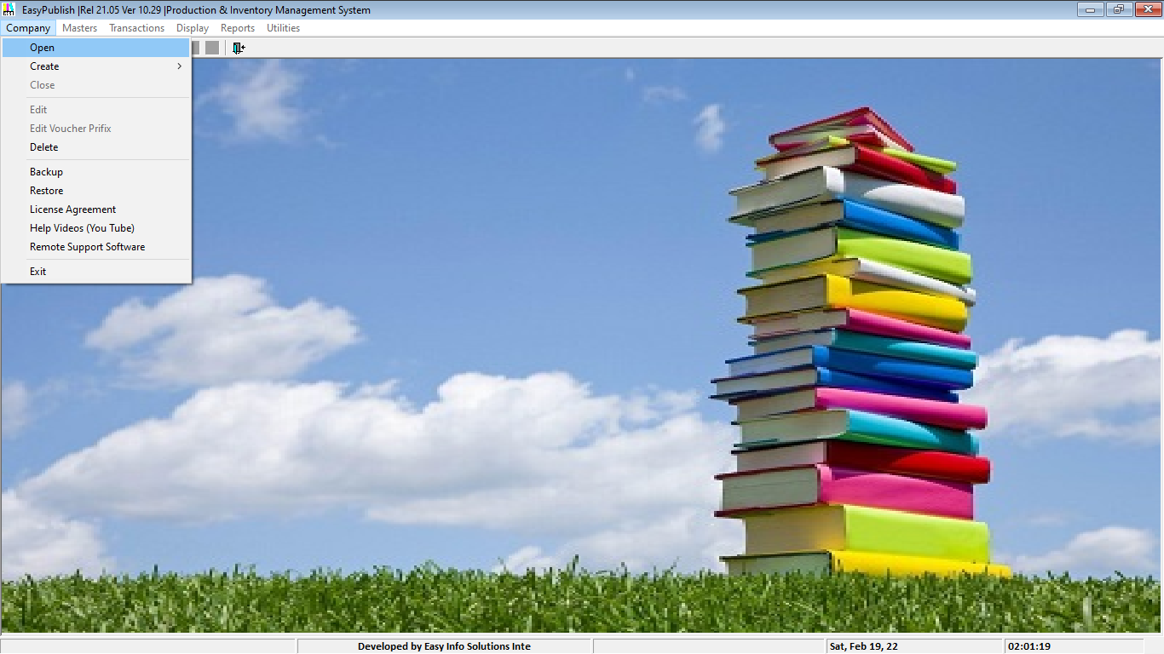

**->>LIST OF COMPANY WINDOWS WILL BE APPEARED**

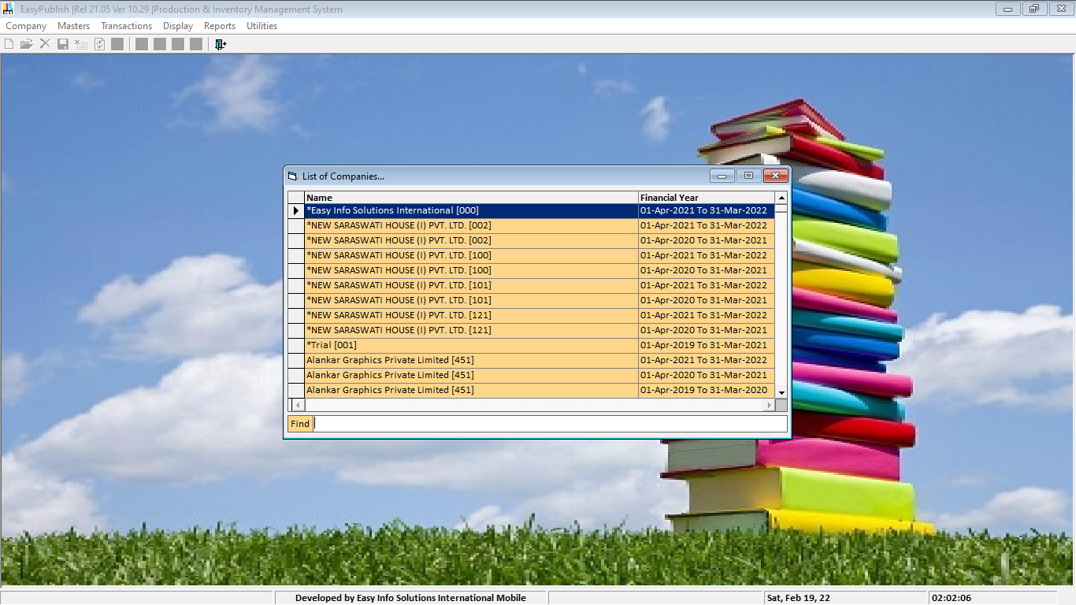

**->>TYPE COMPANY NAME IN FIND BOX**

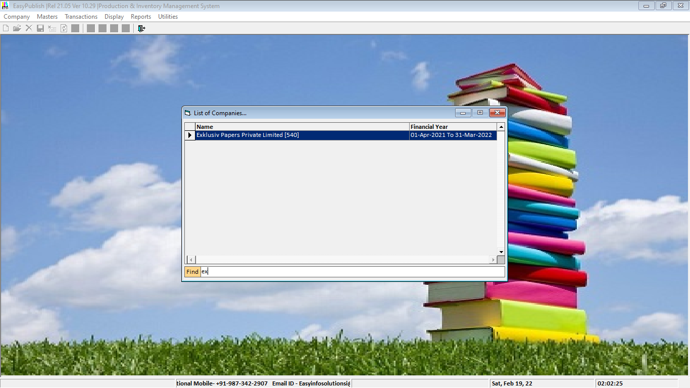

**->>SELECT COMPANY ->>PRESS ENTER->>LOGIN WINDOWS WILL BE APPEARED**

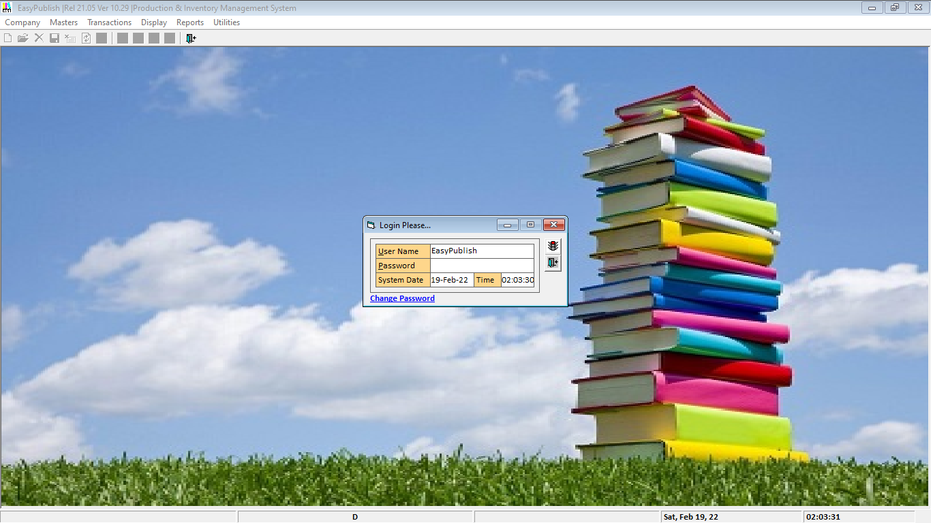

**->> TYPE USER NAME->>TYPE YOUR USER PASSWORD ->>PRESS ENTER->>PRESS ENTER AGAIN**

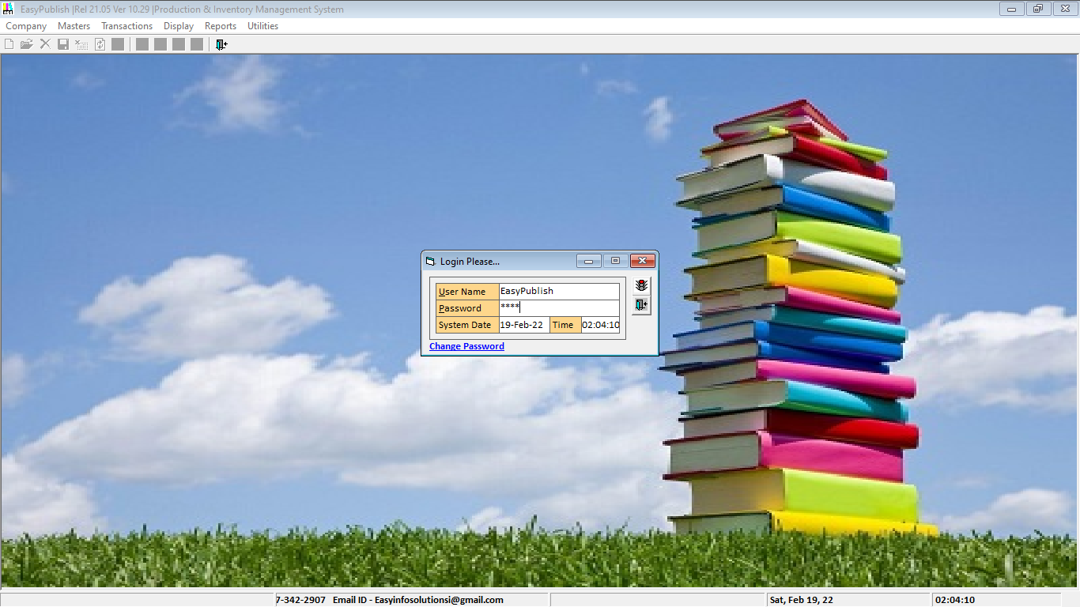

**1.    COST ESTIMATIONS**

Ø **GO TO TAB ->>UTILITIES ->>CLICK ->> COST ESTIMATIONS->>CLICK**

Ø 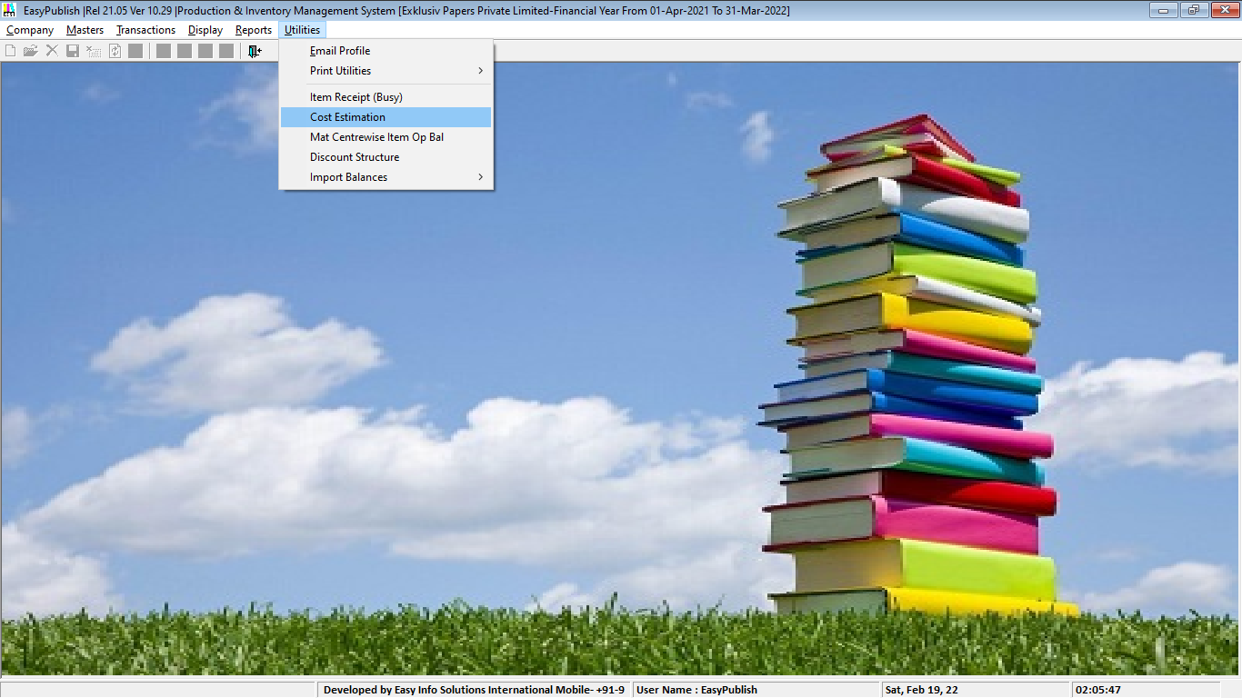

Ø **COST ESTIMATION WINDOWS WILL BE APPEARED IN LIST VIEW**

Ø  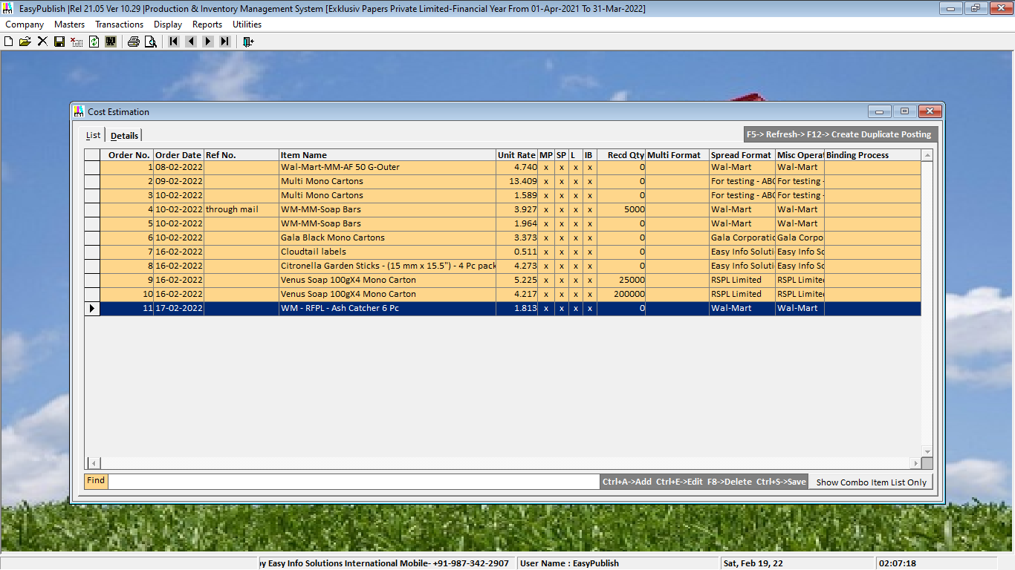

Ø **TO CREATE NEW COST ESTIMATION ->>CLICK       CTRL+A**

Ø **TO EDIT EXISTING COST ESTIMATION ->>CLICK     CTRL+E**

Ø **TO SAVE EXISTING COST ESTIMATION ->>CLICK    CTRL+S**

Ø **TO CREATE NEW COST ESTIMATION ->>CLICK       CTRL+A ->> NEW WINDOWS WILL BE APPEARED IN DETAILS VIEW**

Ø 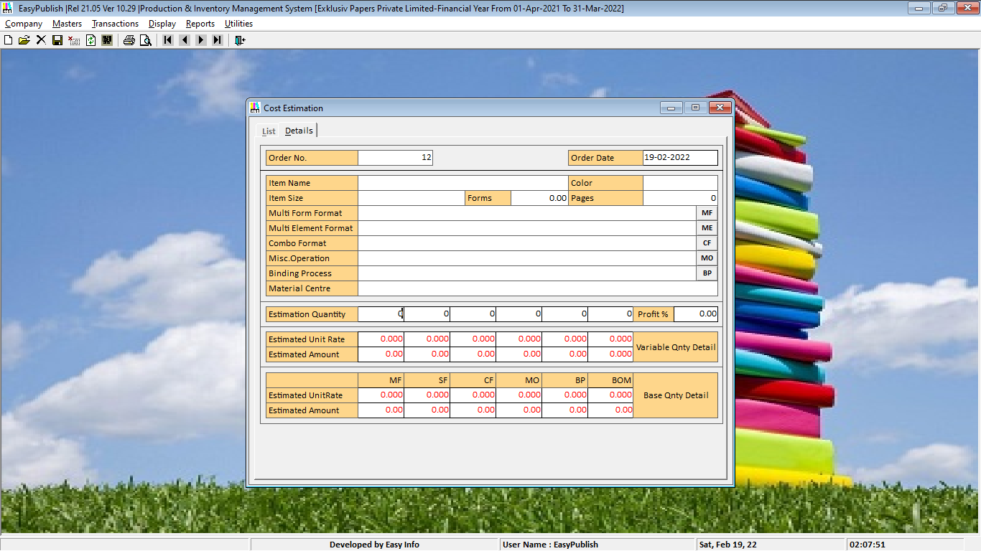

Ø **TYPE COST ESTIMATION QUANTITY IN ESTIMATION QUANTITY BOX**

Ø 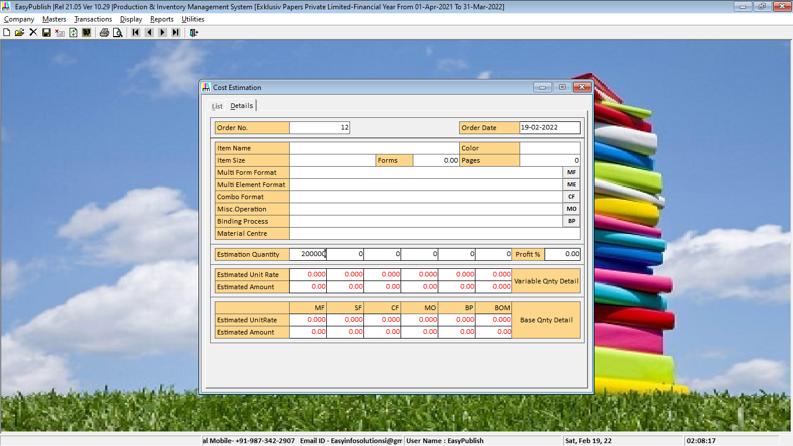

Ø **PRESS ENTER**

Ø 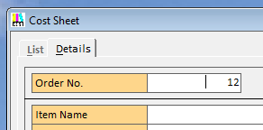

Ø **PRESS ENTER**

Ø 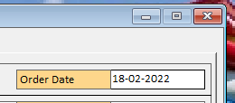

Ø **PRESS ENTER YOU WILL REACHED IN ITEM SELECTION BOX**

Ø 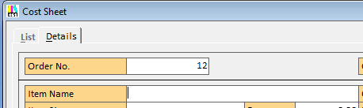

Ø **PRESS SPACE BAR ->> ITEM MASTER LIST VIEW WINDOWS WILL BE APPEARED->> TYPE ITEM NAME IN THIS WINDOWS FIND BOX**

Ø  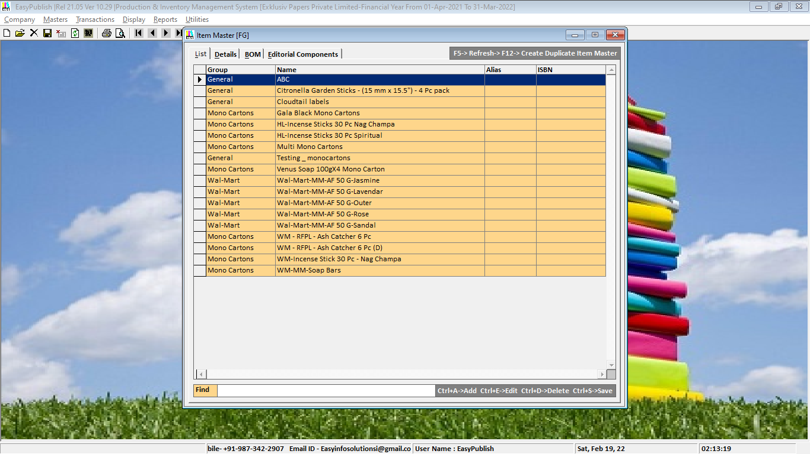

Ø  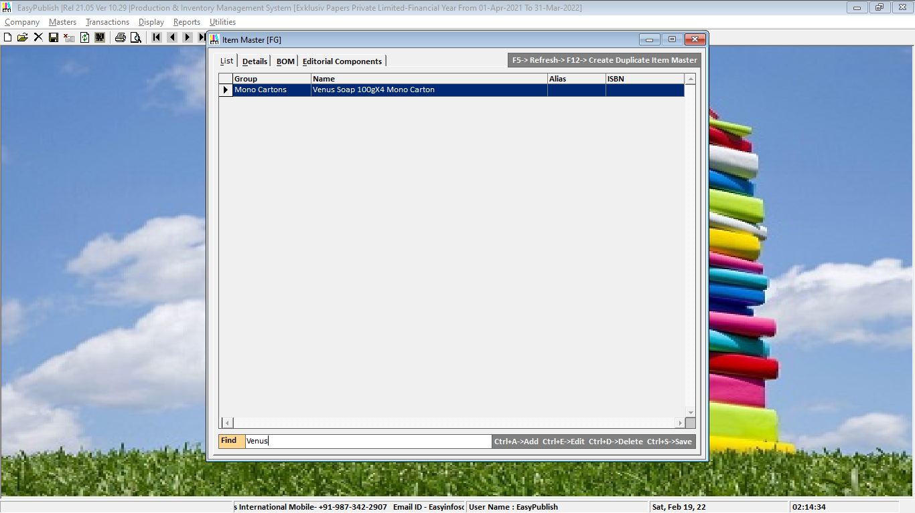

Ø **IF ITEM EXISTING THEN SELECT ITEM IN LIST ->> PRESS ENTER**

Ø **IF ITEM NOT EXISTING THEN SELECT ITEM IN LIST ->> PRESS CTRL + A**

Ø **NEW WINDOWS WILL BE APPEARED IN DETAILS VIEW**

Ø 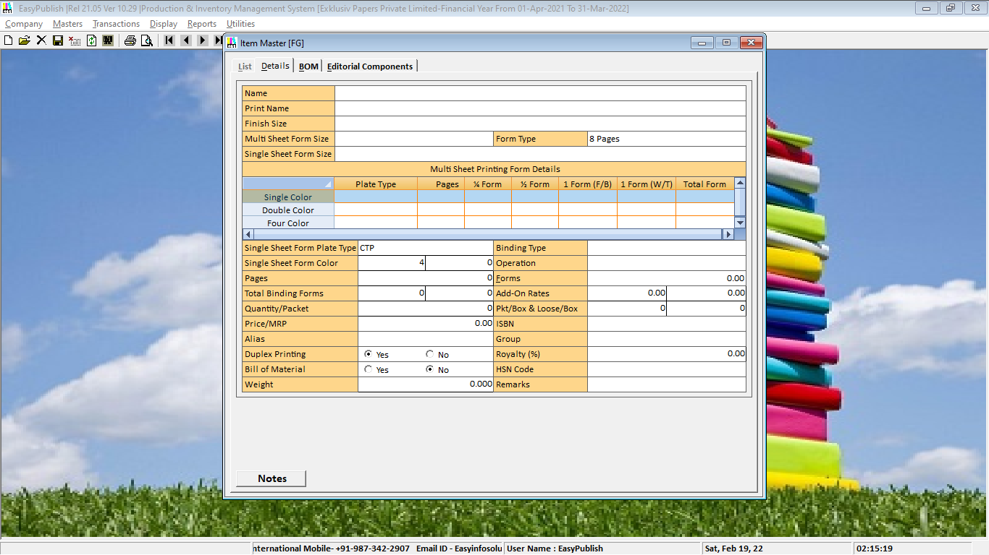

Ø **TYPE YOUR ITEM NAME->> PRESS ENTER->>**

Ø  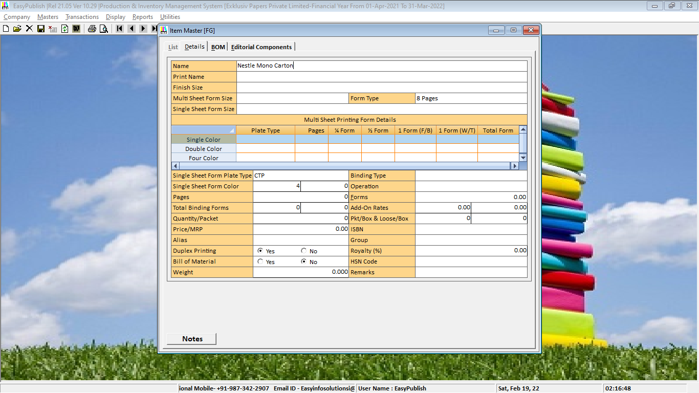

Ø **PRINT NAME AUTOMATICALLY DUPLICATE**

Ø  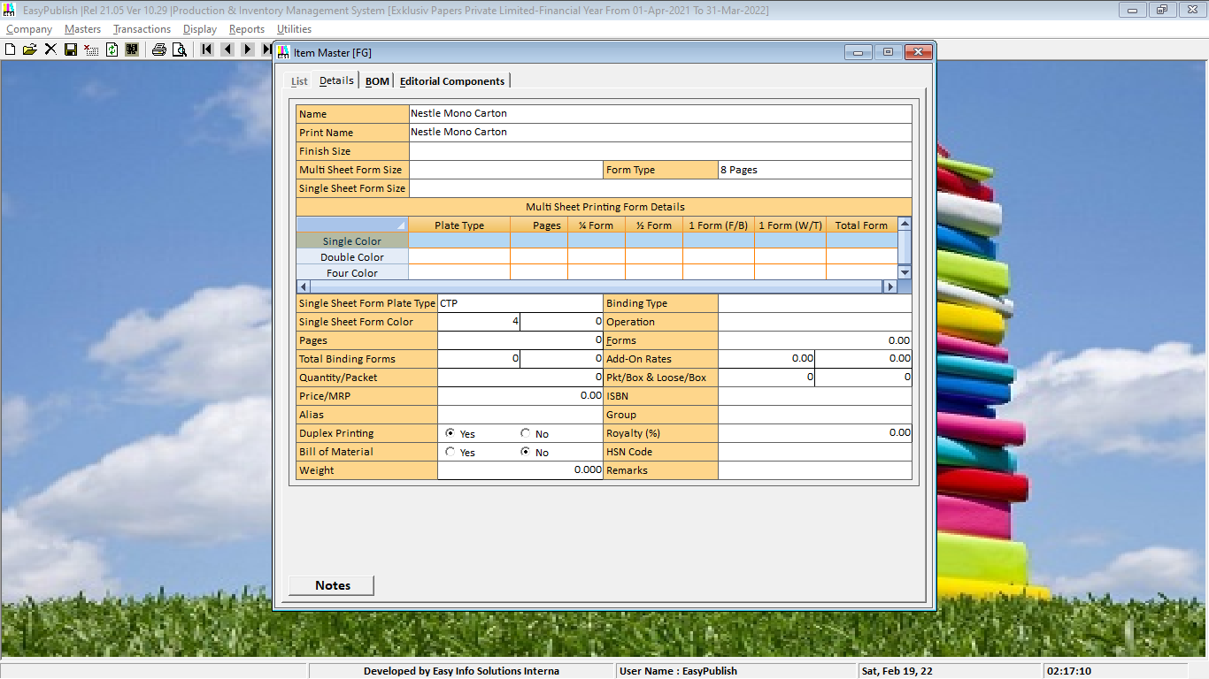

Ø **IF YOU WANTS DIFFERENT PRINT NAME THEN YOU CAN EDIT IT ELSE ->> PRESS ENTER->> THEN YOU WILL REACHED IN FINISHED SIZE**

Ø **INPUT BOX ->> PRESS SPACE BAR->>FINISHED SIZE LIST VIEW WINDOW WILL BE APPEARED->> TYPE FINISH SIZE NAME IN THIS WINDOWS FIND INPUT BOX** 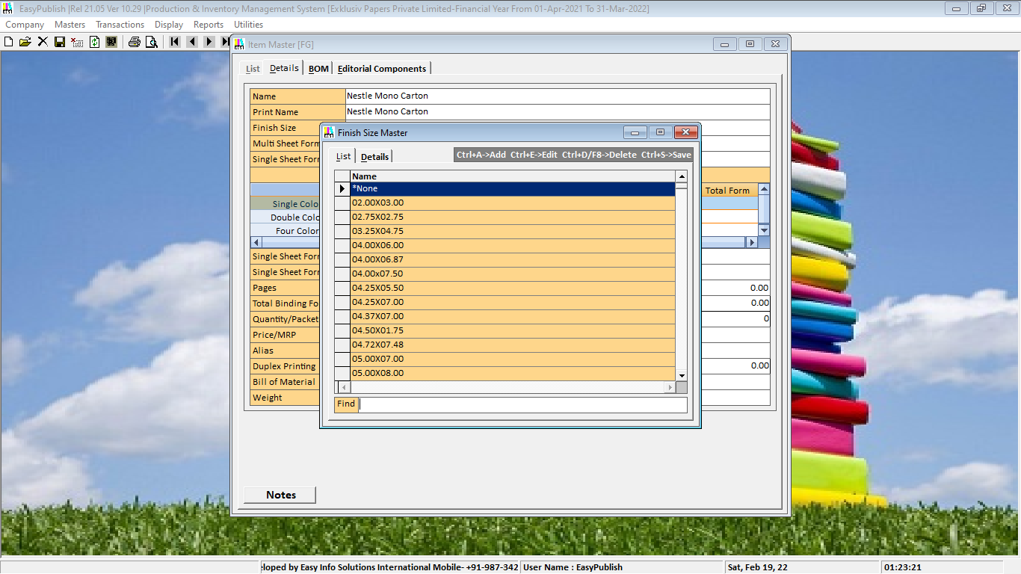

Ø **IF FINISH SIZE EXISTING THEN SELECT ITEM IN LIST ELSE ->> PRESS CTRL + A->> NEW WINDOWS WILL BE APPEARED IN DETAILS VIEW**

Ø 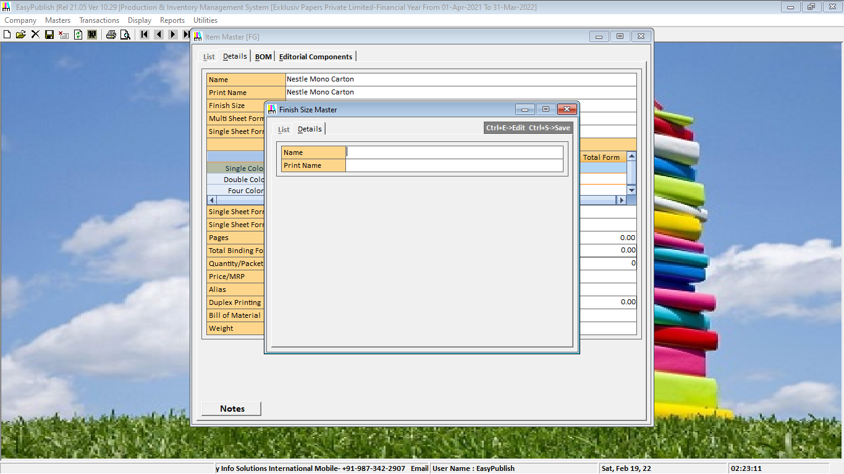

Ø **TYPE YOUR FINISH SIZE**

Ø 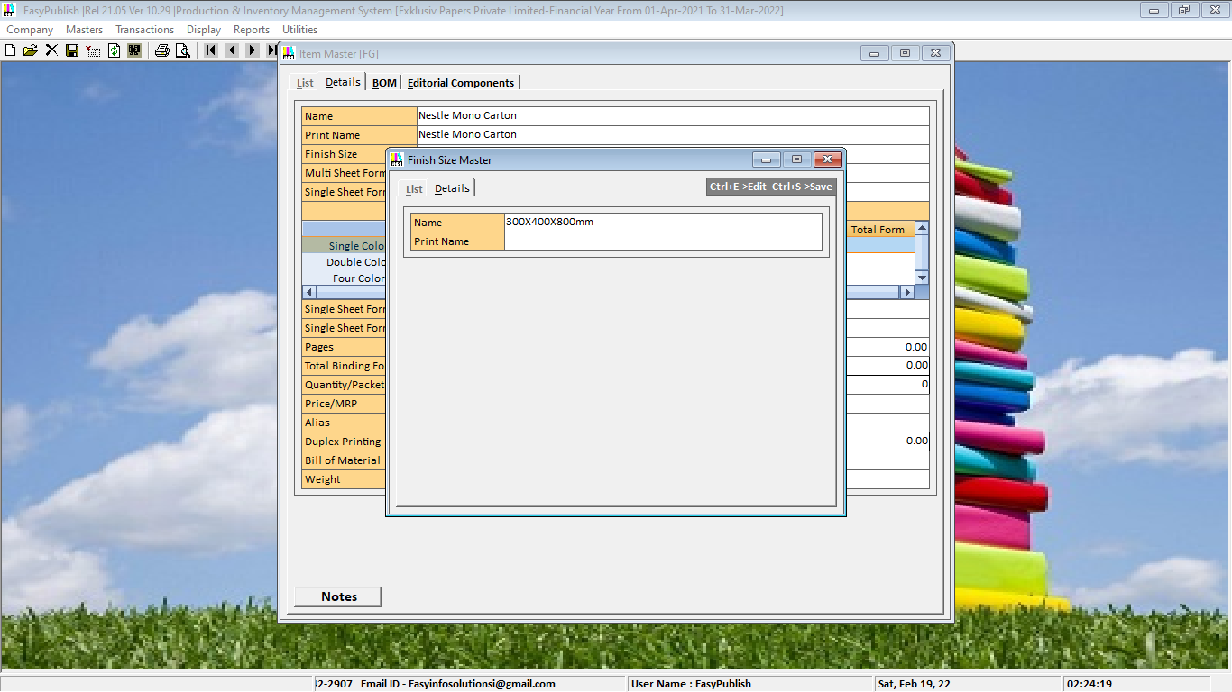

Ø **PRESS ENTER->> PRINT NAME AUTOMATICALLY DUPLICATE**

Ø 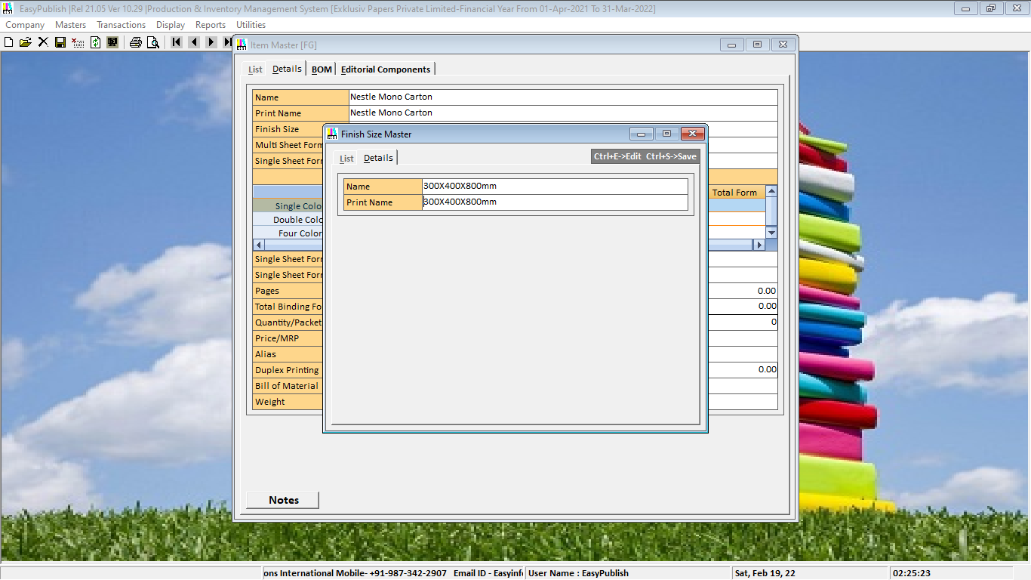

Ø **PRESS->>CTRL+S TO SAVE THIS MASTER->>CLICK TO OK**

Ø 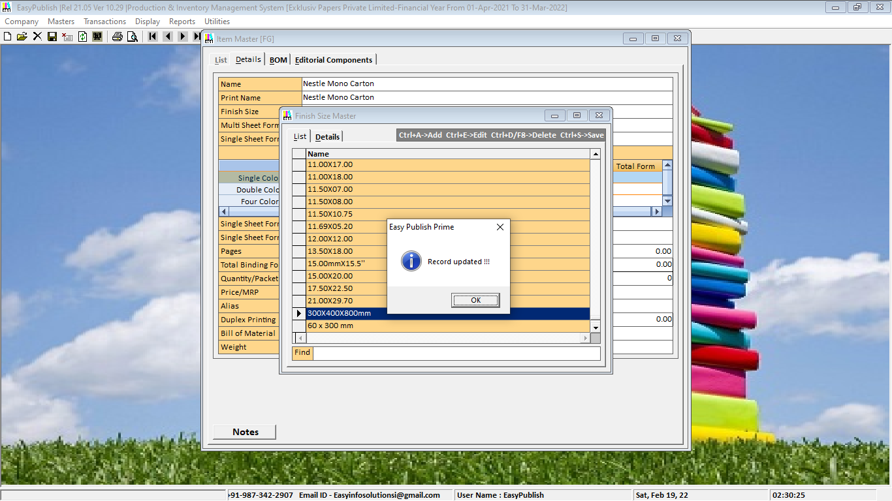

Ø **TO SELECT THIS ->> PRESS ENTER ->> YOU WILL REACHED IN MULTI SHEET FORM SIZE SELECTION BOX**

Ø 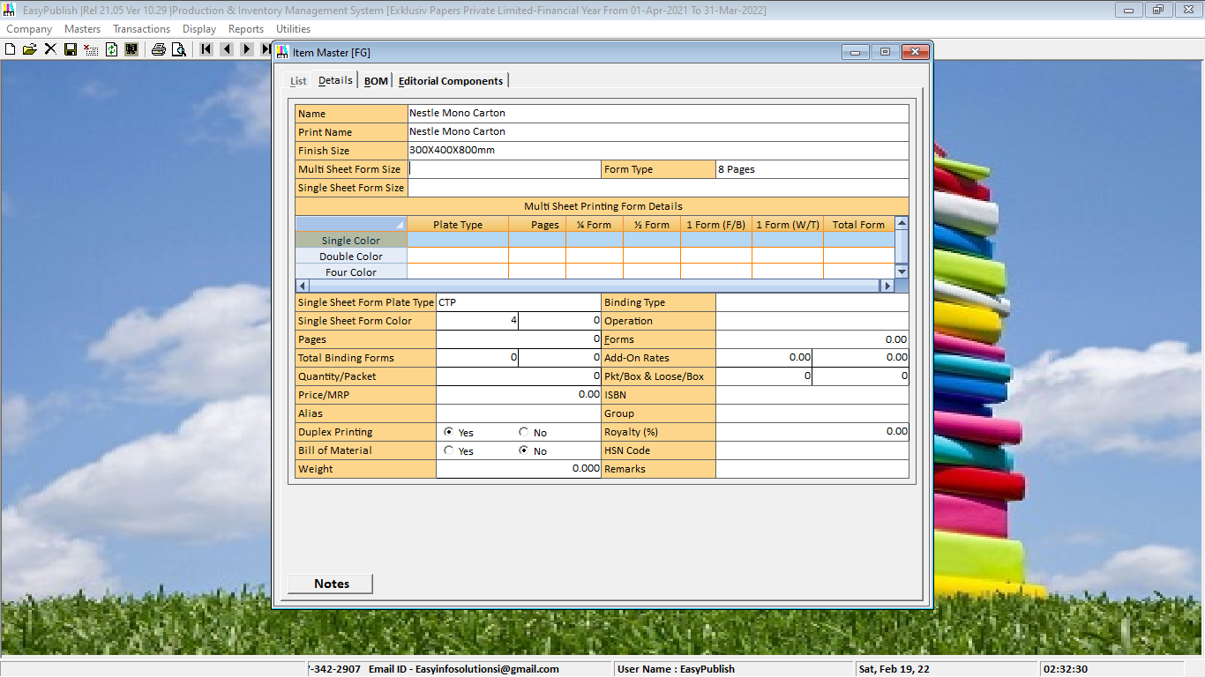

Ø **PRESS SPACE BAR ->> SIZE MASTER LIST VIEW WINDOWS WILL BE APPEARED**

Ø 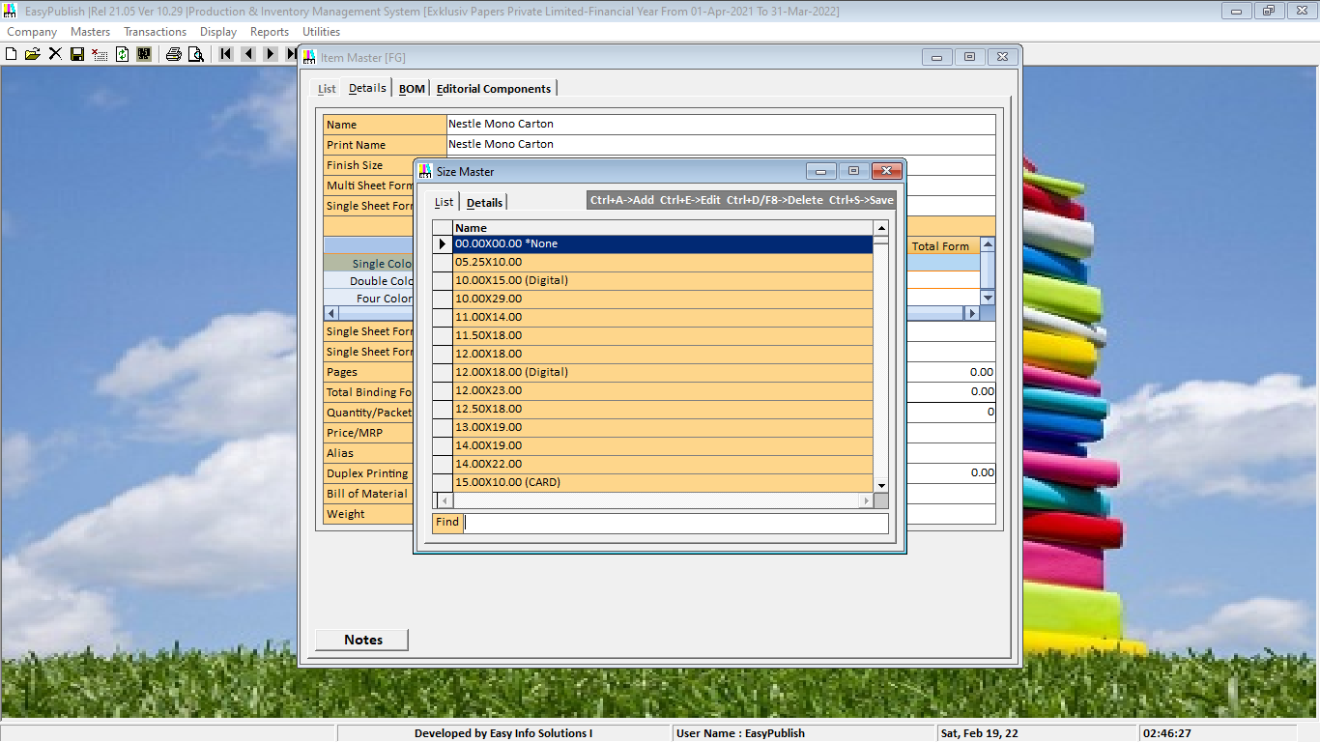

Ø **TYPE SIZE NAME IN FIND BOX->> “*NONE”->> TO SELECT THIS ->> PRESS ENTER**

Ø 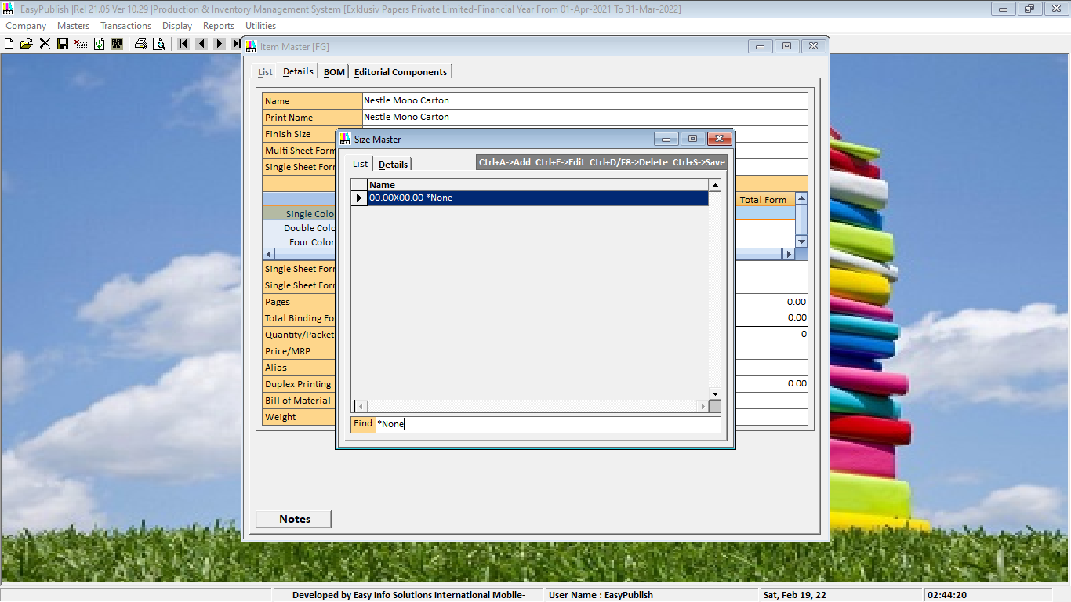

Ø **PRESS ENTER AGAIN->>YOU WILL REACHED IN SINGLE SHEET FORM SIZE SELECTION BOX**

Ø 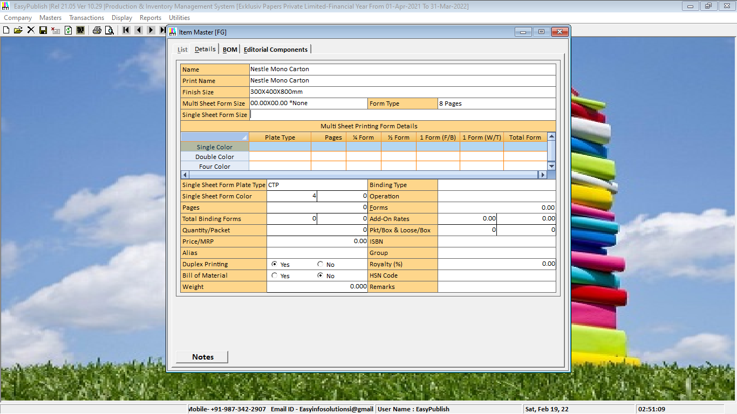

Ø **PRESS SPACE BAR ->> SIZE MASTER LIST VIEW WINDOWS WILL BE APPEARED**

Ø 

Ø **TYPE SIZE NAME IN FIND BOX->>**

Ø 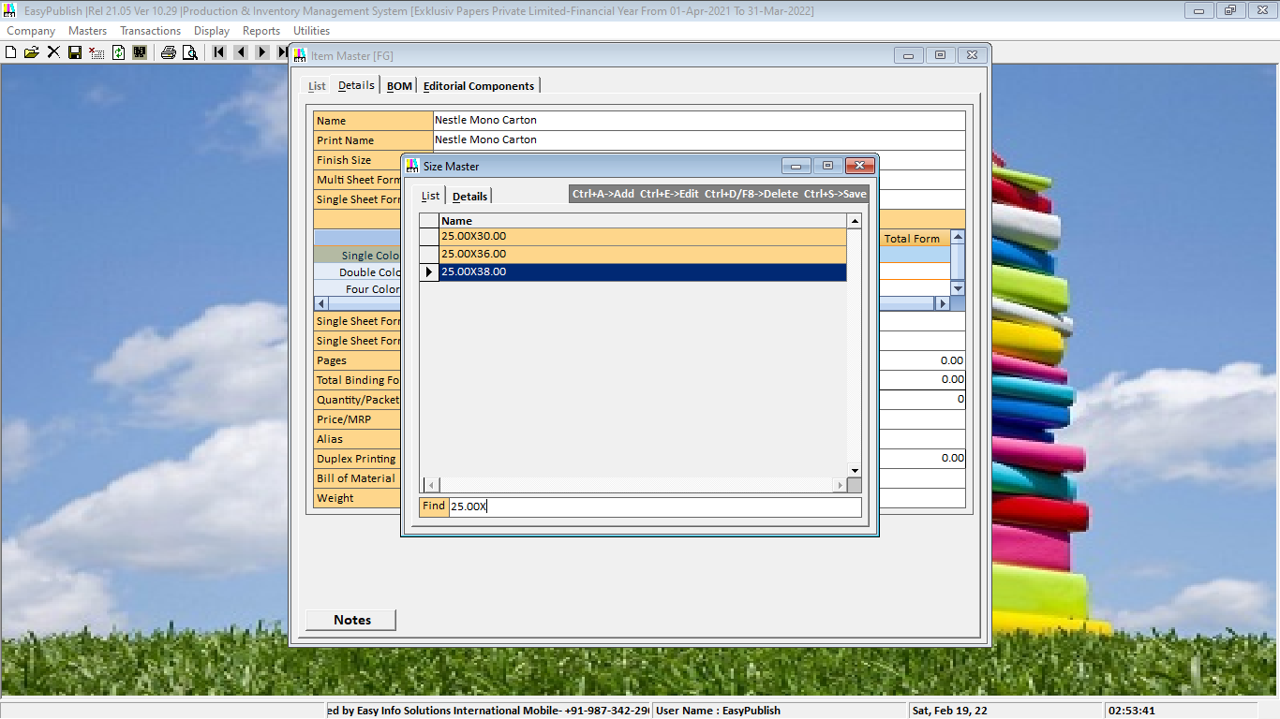

Ø **TO SELECT THIS ->> PRESS ENTER->>PRESS TAB**

Ø 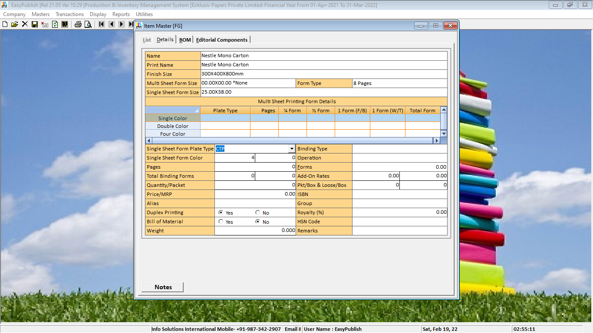

Ø **CLICK ON ->>DROP DOWN ->>TO SELECT SINGLE SHEET FORM PLATE TYPE**

Ø 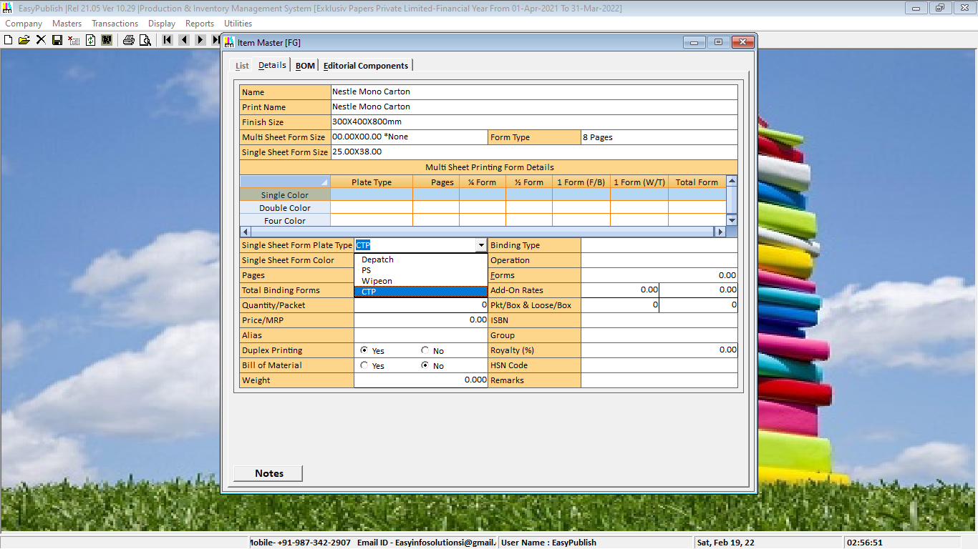

Ø **CLICK ON ->>SELECTION ->>PRESS ENTER**

Ø 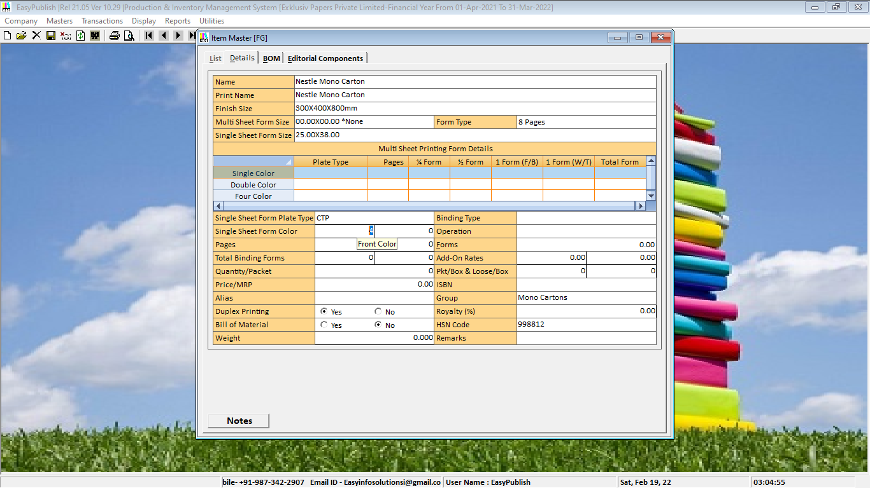

Ø **TYPE NO OF COLOR OF SINGLE SHEET FORM->>PRESS ENTER EIGHT TIMES->>**

Ø **THEN YOU WILL REACHED TO ITEM GROUP SELECTION WINDOWS ->>**

Ø **PRESS SPACE BAR ->> ITEM GROUP MASTER LIST VIEW WINDOWS WILL BE APPEARED**

Ø 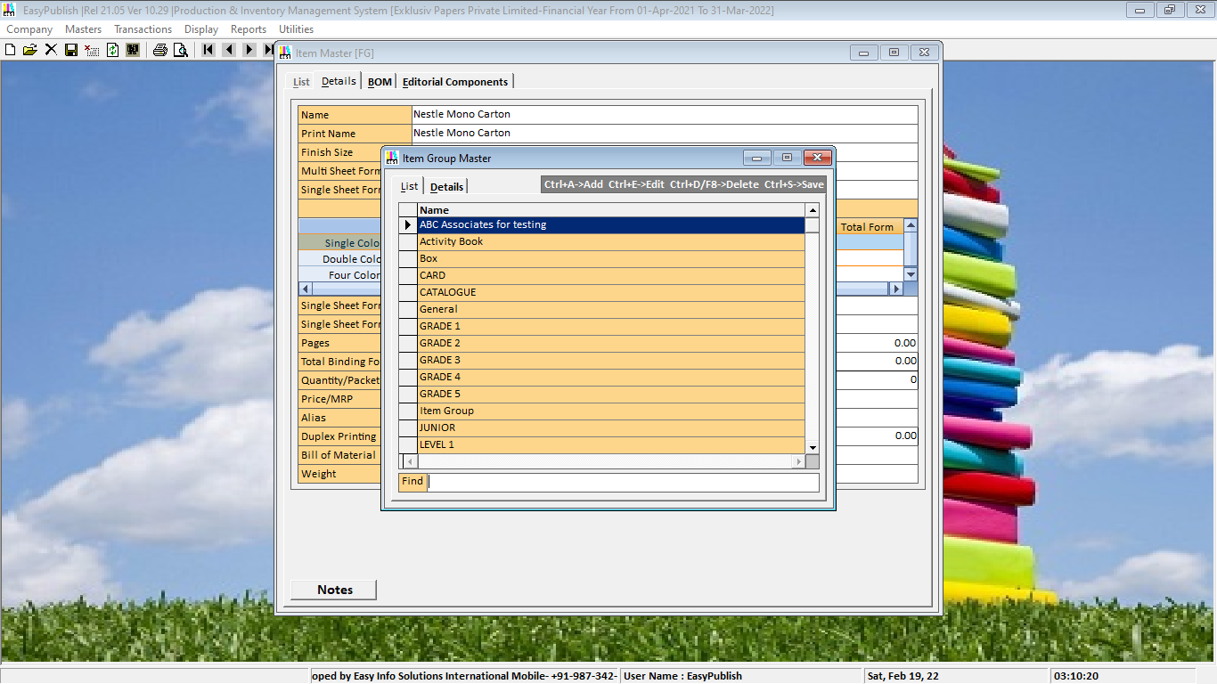

Ø **->> TYPE ITEM GROUP NAME IN FIND BOX**

Ø 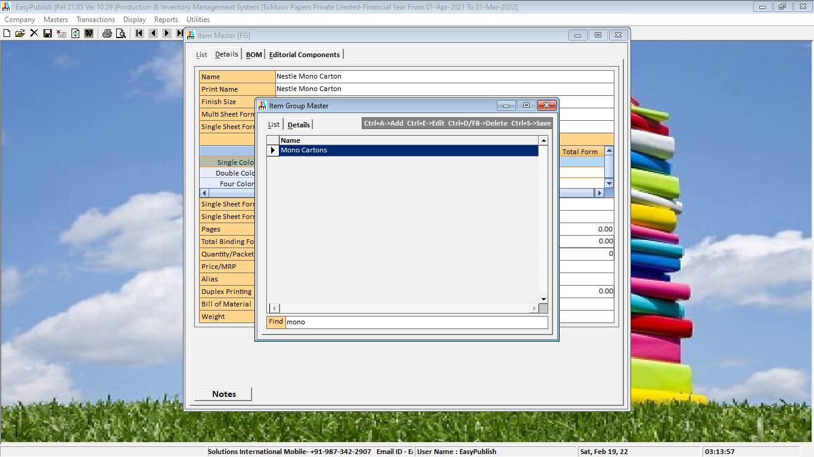

Ø **TO SELECT THIS ->> PRESS ENTER THREE TIMES**

Ø **YOU WILL REACH ITEM HSN CODE BOX ->> PRESS SPACE BAR**

Ø 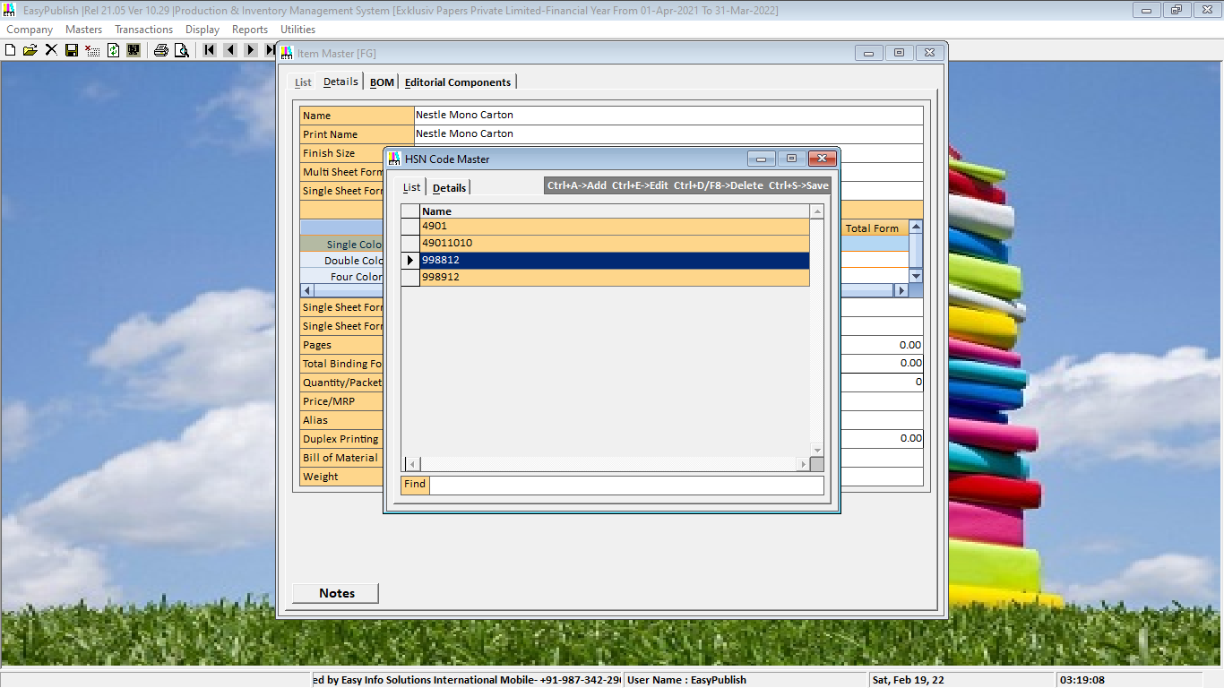

Ø **PRESS ENTER->> TO SELECT THIS**

Ø **PRESS->>CTRL+S TO SAVE THIS MASTER->>CLICK TO OK**

Ø 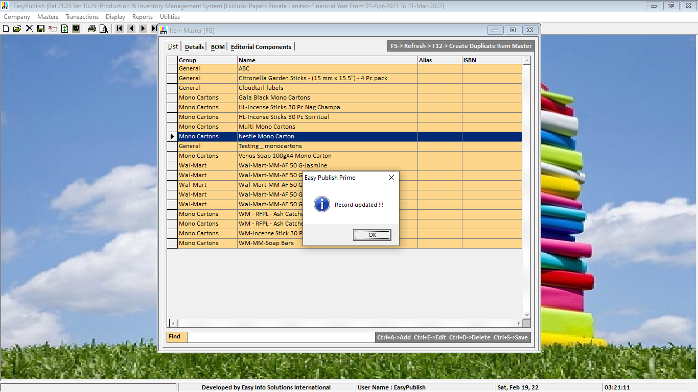

Ø **TO SELECT THIS ->> PRESS ENTER ->> PRESS TAB TWICE->>**

Ø **YOU WILL BE REACHED IN MULTI ELEMENT FORMAT ACCOUNT SELECTION BOX (IN WHICH ACCOUNT YOU WANTS TO DO COST ESTIMATION)**

Ø **PRESS SPACE BAR ->> ACCOUNT MASTER LIST VIEW WINDOWS WILL BE APPEARED**

Ø 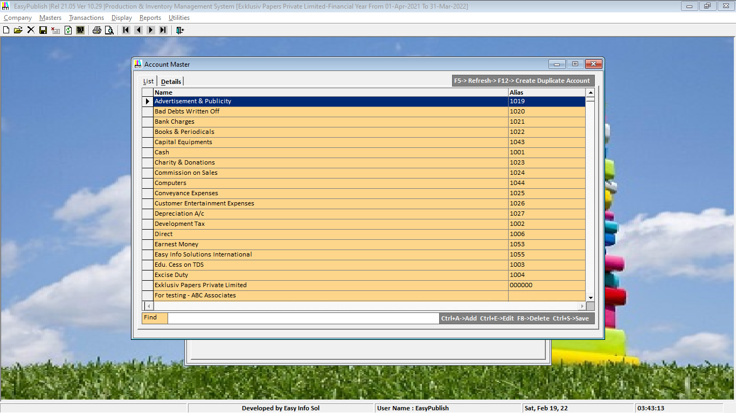

Ø **->> TYPE ACCOUNT NAME IN FIND BOX**

Ø 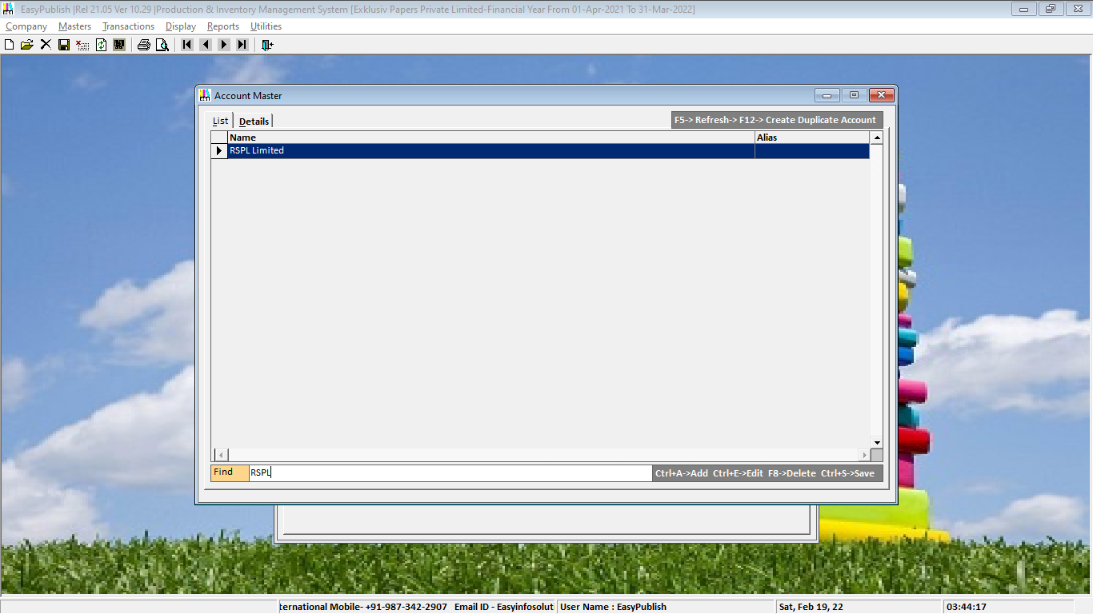

Ø **TO SELECT THIS ->> PRESS ENTER->>MULTI ELEMENT PRINTING FORM ORDER DETAILS WILL BE APPEARED**

Ø 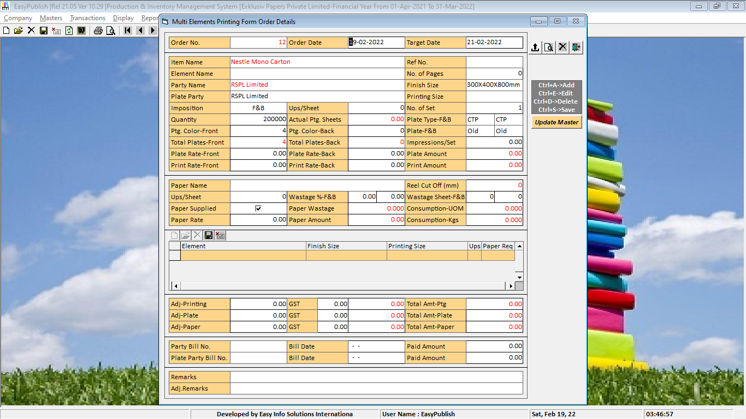

Ø **PRESS ENTER THREE TIMES->>PRESS SPACE BAR->>LIST OF ELEMENT WILL BE APPEARED**

Ø 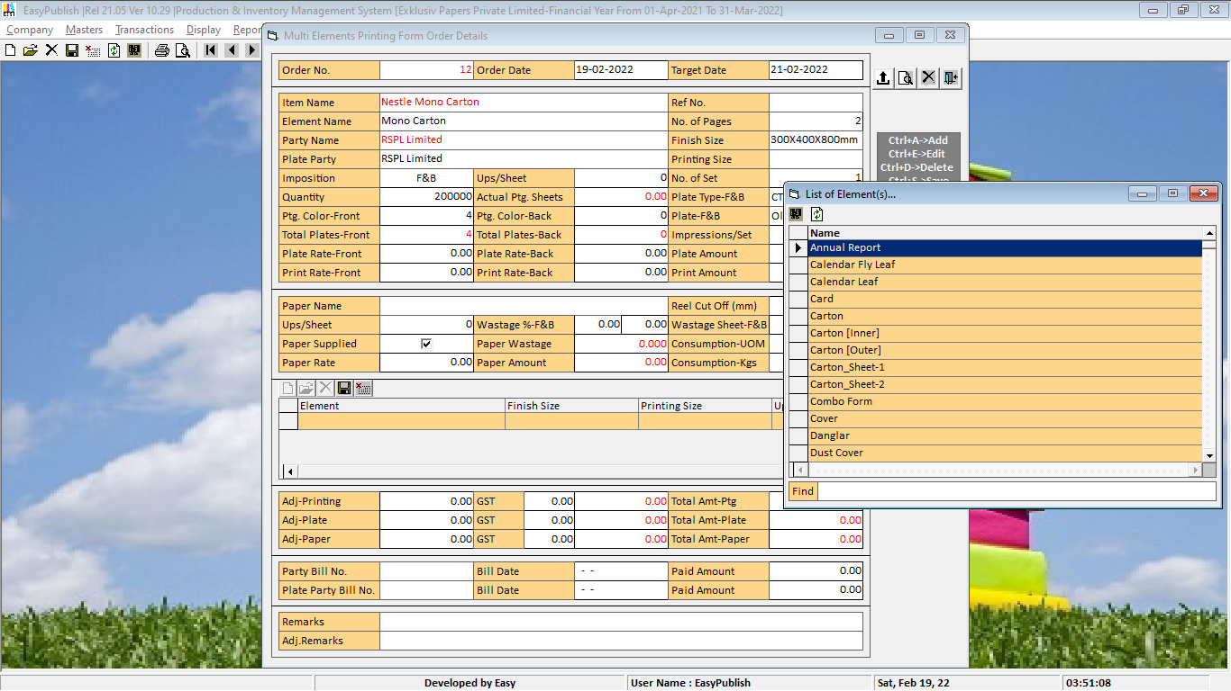

Ø **->>TO SEARCH ELEMENT TYPE ELEMENT NAME IN FIND BOX->>PRESS ENTER THREE**

Ø 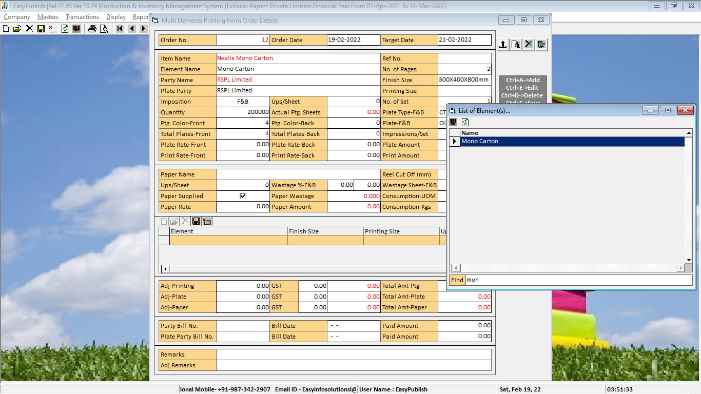

Ø **YOU WILL BE REACHED PRINTING SIZE BOX (IN WHICH SIZE YOU WANTS PRINT JOB)**

Ø **PRESS SPACE BAR ->> PRINTING SIZE MASTER LIST VIEW WINDOWS WILL BE APPEARED->> TYPE PRINTING NAME IN FIND BOX**

Ø 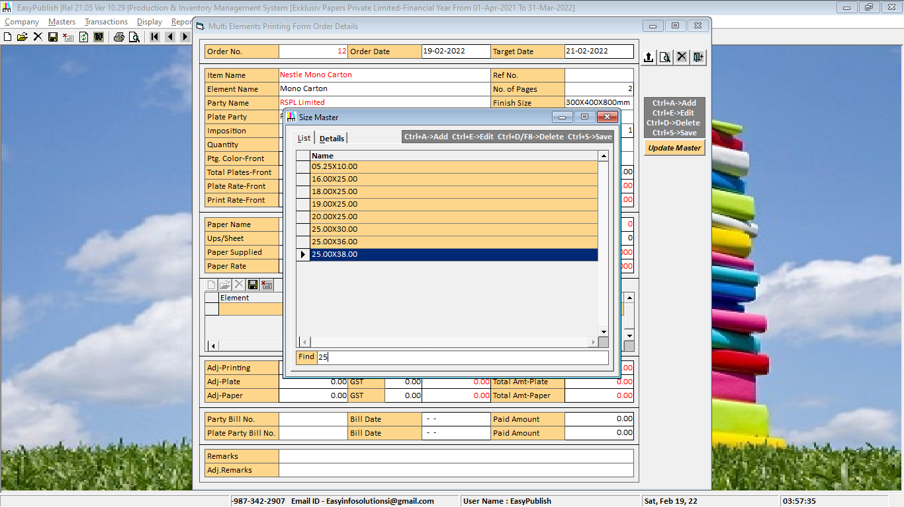

Ø **PRESS ENTER THREE TIME**

Ø **PROVIDE CERTAIN INPUTS ..**

Ø **IMPOSITION->>F&B**

Ø **IMPOSITION->>W&T**

Ø **UPS/SHEET**

Ø **PLATE TYPE**

Ø **PLATE RATE**

Ø **PRINTING RATES**

Ø **AT LAST REACH IN PAPER NAME ->>PRESS F3**

Ø **PAPER MASTER WINDOW WILL BE APPEARED**

Ø **TYPE PAPER NAME YOU WANTS**

Ø 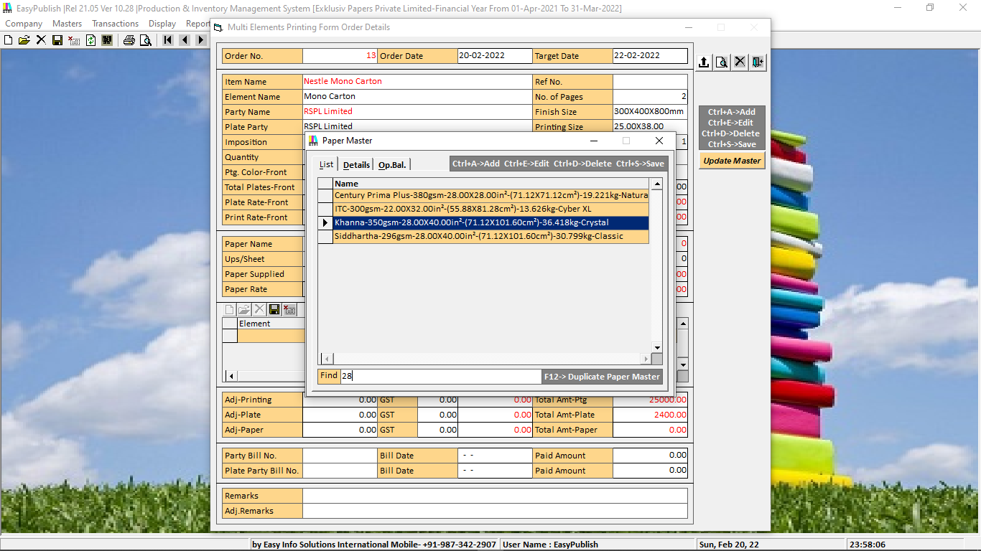

Ø **AS PER JOB REQUIREMENTS, IF YOU ARE SELECTING DIFFERENT SIZE OF PAPER, THEN SOFTWARE WILL BE AWARE YOU BY SHOWING ALERT.**

Ø 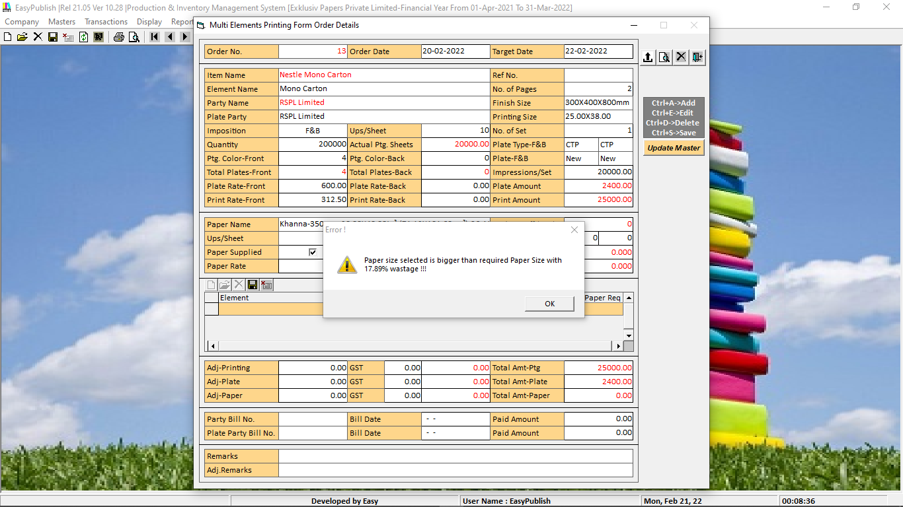

Ø **CLICK OK IF YOU WANT TO GO WITH SAME PAPER ELSE SELECT DIFFERENT PAPER.**

Ø **THEN PROVIDE THE REMAINING INPUTS … REEL CUT OFF (IN MM IF YOU ARE SELECTING REEL PAPER), UPS/PER SHEET, WASTAGE % FRONT, WASTAGE % BACK, MIN WASTAGE FRONT, MIN WASTAGE FRONT, SELECT PAPER SUPPLIED BY PARTY TICK THE CHECK BOX ELSE TYPE PAPER RATE PER KG., ADJUSTMENT-PRINTING, GST—PRINTING, ADJUSTMENT-PLATE, GST-PLATE, ADJUSTMENT-PAPER, GST-PAPER**

Ø **IF YOU HAVE ANY KIND OF ADJUSTMENT THEN TYPE ADJUSTMENT REMARK**

Ø **PRESS CTRL+S OR CLICK ON SAVE ICON**

Ø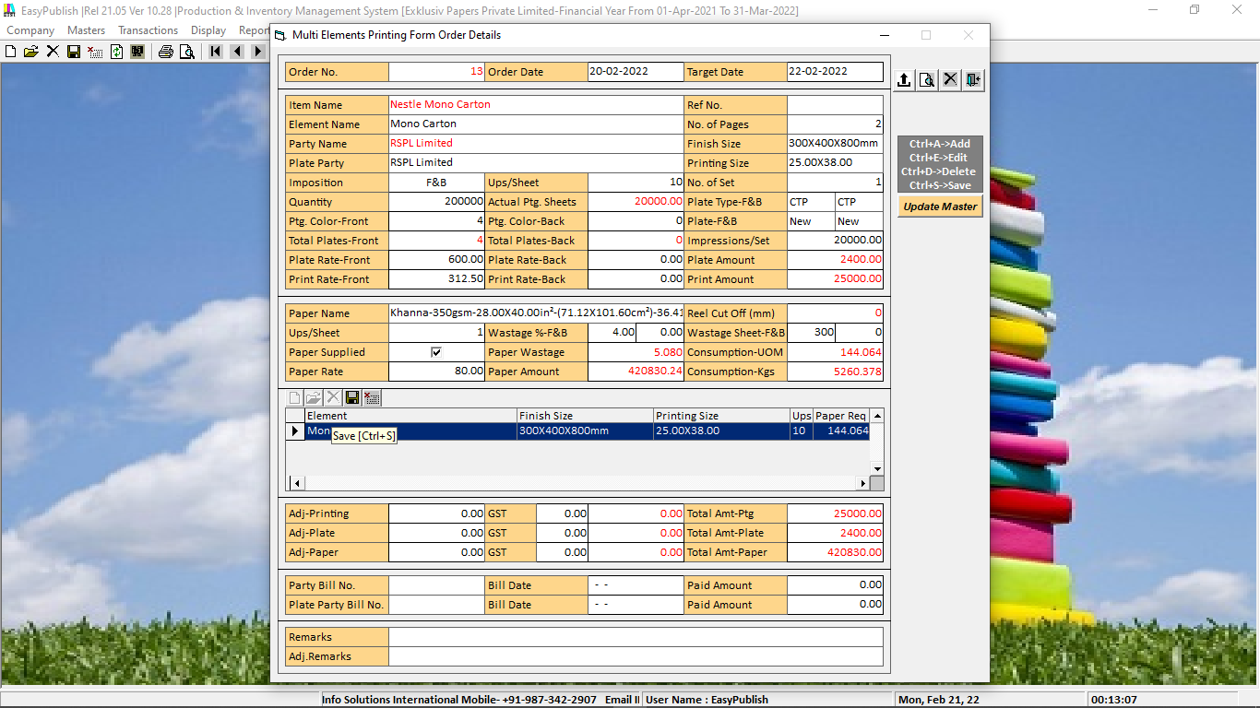

Ø **THEN CLICK SAVE BUTTON TO SAVE AND CLOSE THIS FORM**

Ø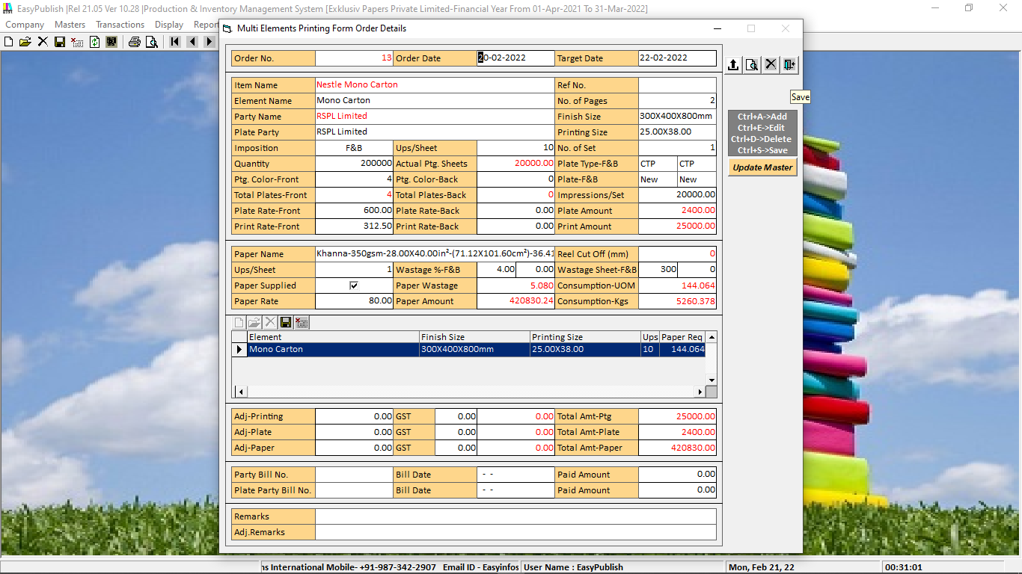

Ø **THEN GO TO MISC. OPERATION ->> PRESS SPACE BAR->> ACCOUNT MASTER WINDOW WILL BE APPEARED->> Select The Party Name**

Ø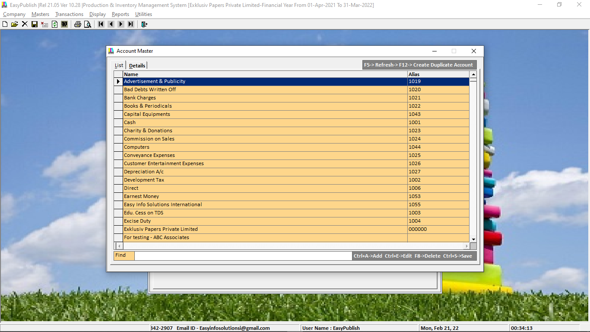

Ø **Miscellaneous Operations Order Details Window will be Appeared->> Twelve type of inputs required->> Element Name, Operation Name, How Many Times/No. Operation will be repeat, Describe the or relate the “No.” with Operation (Like. Side, No., Section, Form), Size (You must select accurate size if you are selecting any squire in Calculations, Type of Operation Calculation Mode, Calculation Value will be automatically appeared, Rate, Adjustment, GST.**

Ø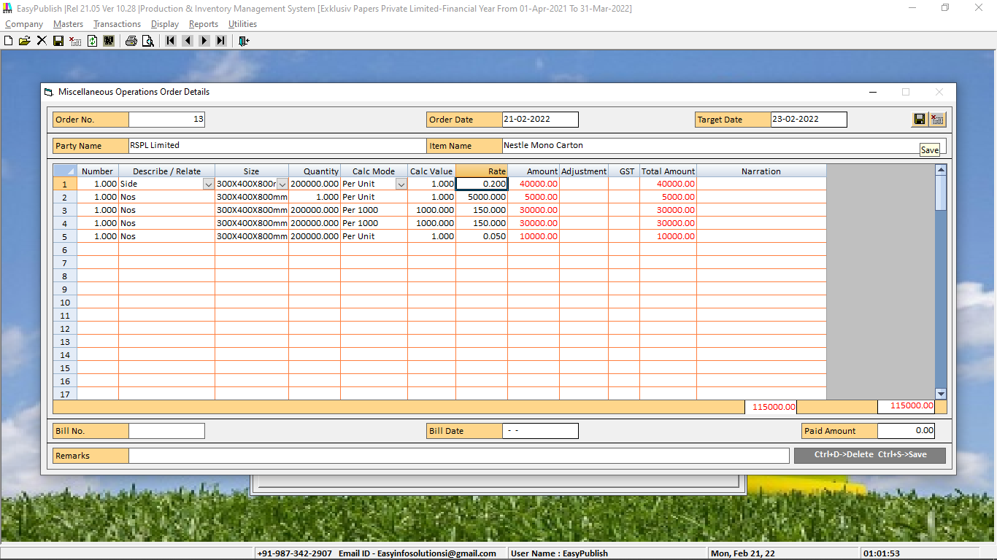

Ø **Press CTRL+S Or CLICK ON SAVE BUTTON->> Then you will come back on COST ESTIMATION FORM ->> Then Go to Material Centre ->> Press Space BAR->> Select MATERIAL CENTRE->>Press CTRL+S**

**->>Press CTRL+S OR Click ON SAVE BUTTON->>**

Ø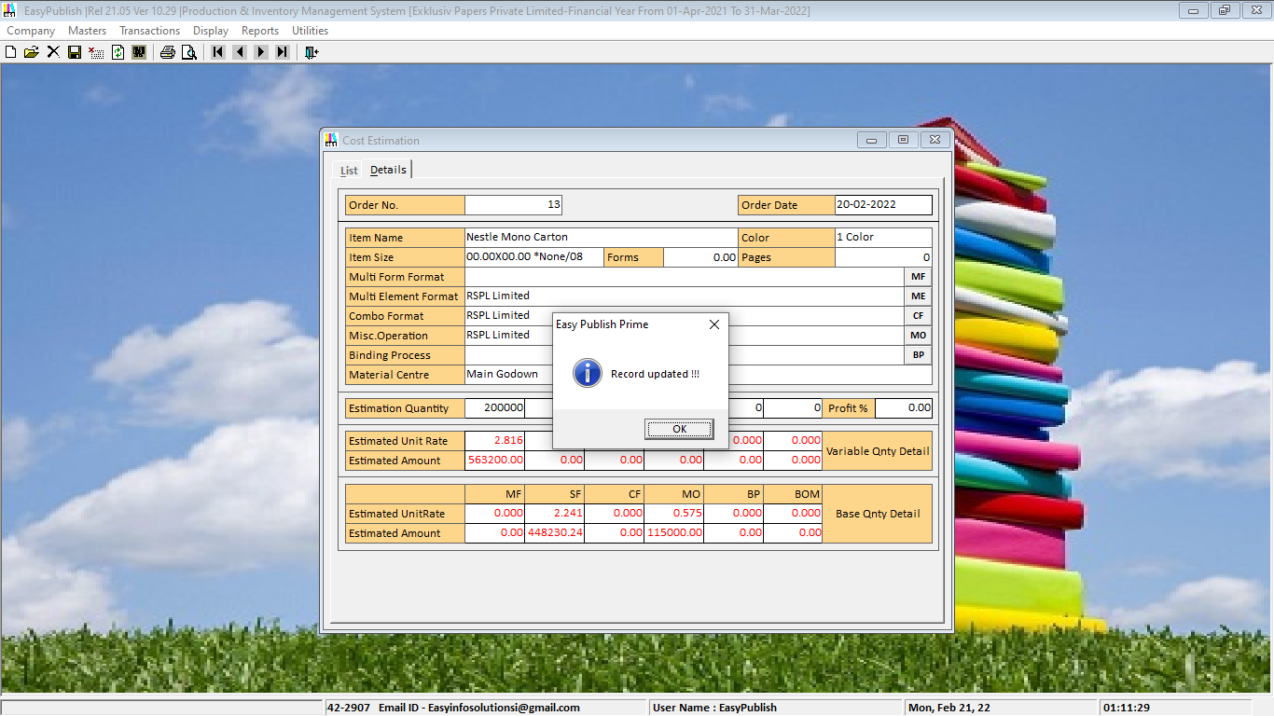

Ø **Click On Print Preview ICON->> JOBWORK->>ALL->>**

Ø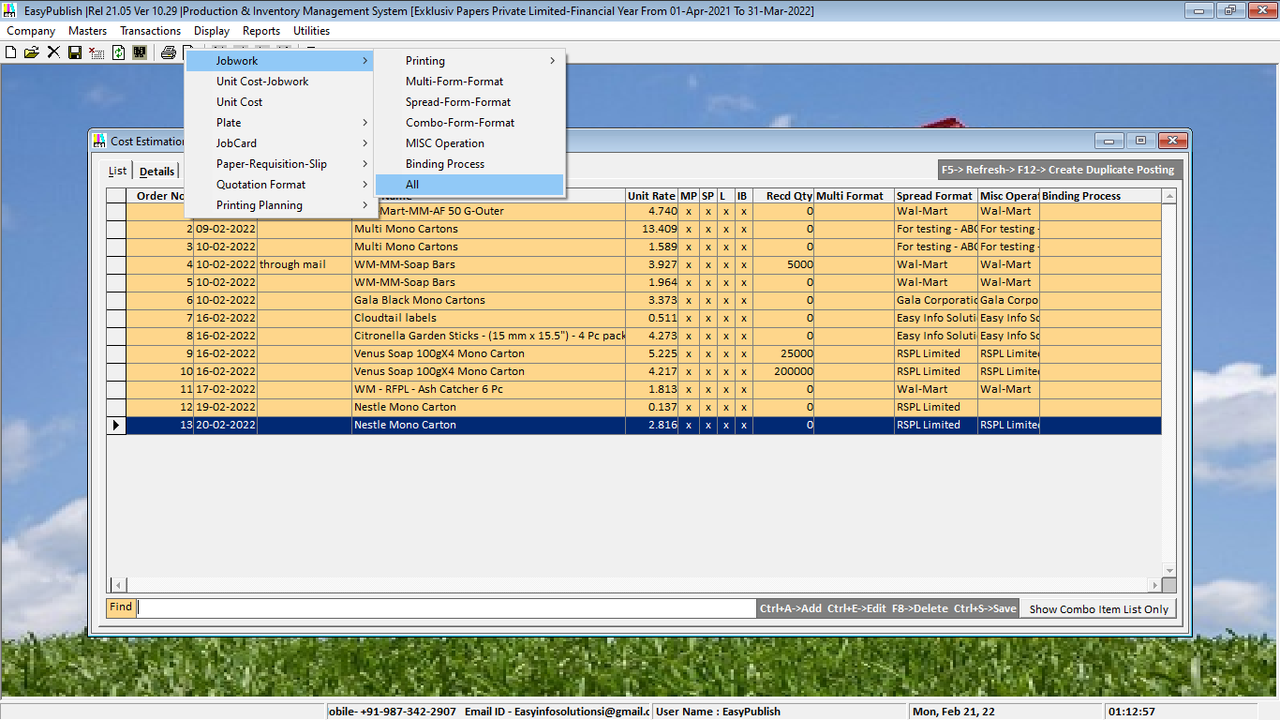

Ø**THEN You WLL GET ->>Quotation/Estimation Print-out**

Ø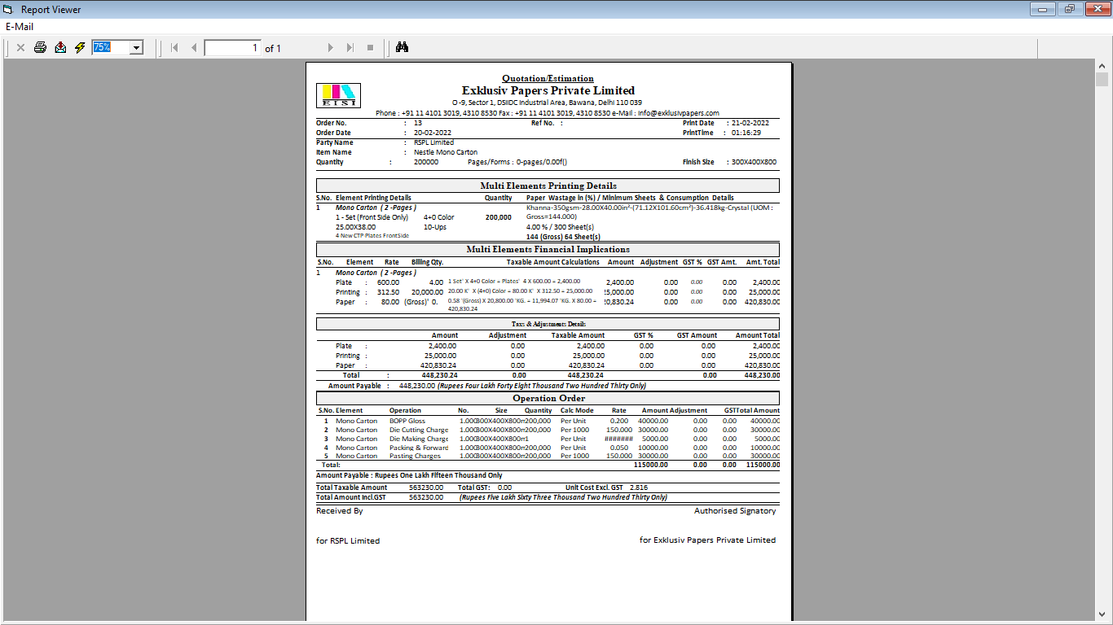

|  |  |
| --- | --- |
| **SEE ALSO** | **BACK TO TOP** |
| **ADMINISTERING A COMPANY**  **ENTERING TRANSACTIONS FOR A COMPANY****,** **USERS** |  |

 COPYRIGHT © EASY INFO SOLUTIONS INTERNATIONAL, INDIA